**Animated Sign Language Processing:**

**FBX format:**

* Animation format used in almost animated applications.
* One file can contain multiple objects with more than one animation.
* Easy to use and modify using FBX **software development kit ‘SDK’.**

So, We stored our sign language animation in **FBX** format then we processed it using **FBX SDK.**

**Fbx Scene:** A scene can contain one or more animation stacks.

**Fbx Animation Stack**: The animation stack is the highest-level container for the animation data and contains one or more animation layers.

**Fbx Animation Layer**: An animation layer contains one or more animation curve nodes that are connected to the animation curves.

**Fbx Object**: A FBX object can contain zero or more FBX properties.

**Fbx Property**: A FBX property is strongly typed data that belongs to a FBX object. To animate a scene, you can set the appropriate FBX properties (Translation, Rotation, Scaling is the most common) contained in the FBX objects.

**Fbx Animation Curve**: An animation curve, also known as function curve or FCurve defines how a FBX property of a FBX object is animated or different from the default value in the animation layer. The animation curves are connected to the animation curve nodes. The same animation curve can be connected to multiple animation curve nodes regardless of the referred FBX property. Accordingly, one animation curve can animate many FBX properties of many FBX objects.

**Fbx Animation Curve Node**: An animation curve node is the connection point between the animation curves and the FBX properties. To connect an animation curve to a FBX property, you can connect the animation curve and the FBX property to one animation curve node.

**Fbx Animation Curve Key:** A key or keyframe marks the beginning and the end of an animation curve.

The following UML class diagram shows the interrelationships of classes in a **FBX** scene.

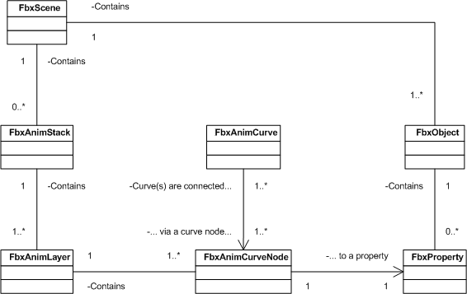

**3. Generate the sign language animation file:**

Input: Sequence of animations IDs.

Output: Animation file contains the Translated Sign Language.

Process name: Generate Animation sequence.

Process:

1. For each ID in sequence:
2. Load the scene from the animation file of that ID.
3. Extract the Animation Stack (in our data set, every file has only one animation stack).
4. Extract the Animation Layer from Animation stack (we didn’t use blended animation, so, we extract only one layer).
5. Call Merge animation layers subroutine to merge the Animation Layers.
6. Create a new scene with one Animation stack.
7. Add the merged layers to that created stack in the scene.
8. Save the scene to the output file.

Merge animation layers subroutine:

Input: The animation layer of the first scene and the animation layer of the second scene and the root node of the first layer and the root node of the second layer

Output: animation layer contains the two merged layers

Process name: Merge animation layers

Process:

1. Call Merge Channels subroutine.
2. For each child node recursively, call Merge animation layers with the same Animation layers and child nodes.

Merge Channels subroutine:

Input: Animation layer of the first scene and the animation layer of the second scene and the root node of the first layer and the root node of the second layer.

Output: merged channels of animation layers nodes.

Process name: Merge Channels

Process:

For each property (translation, rotation, scaling, ….)

* Get Animation Curve for the first node from the first animation layer.
* Get Animation Curve for the second node from the second animation layer.
* Call Merge Curve subroutine.

Merge Curve subroutine:

Input: two Animation curves

Output: Merged Animation curve

Process name: Merge Curve

Process:

1. Get the number of key-frames of the second curve.
2. Save the time of the last key-frame of the first curve.
3. For each key-frame of the second curve:
   1. Get the time and value of that key-frame.
   2. Add new key-frame to the first curve with time equal to sum of the last key-frame of the first curve and the current key-frame.
   3. Set the value of the added keyframe with the current value.
   4. Set the interpolation of the added keyframe with the curve 2 interpolation.

4. Display the animated sign language